### **Names:**

**Band 1: Color:**

**Width(mm): Thickness (mm): A0(mm2): Length L0 (mm):**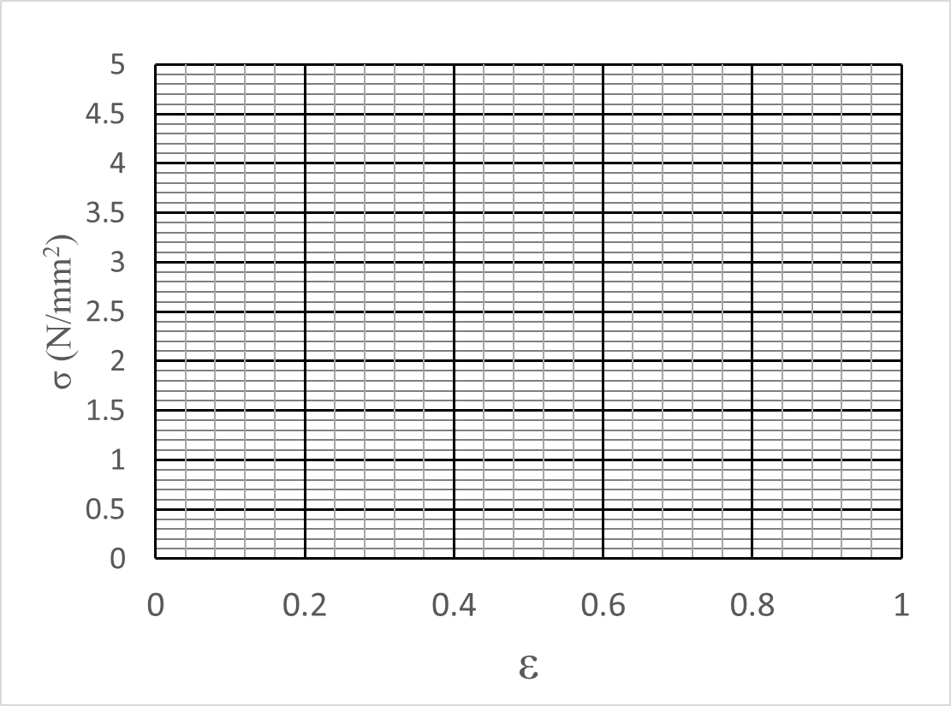

|  |  |  |  |
| --- | --- | --- | --- |
| **F (N)** | **F/A0 =σ**  **(N/mm2)** | **ΔL** | **ε=ΔL/L0** |
|  |  |  |  |
|  |  |  |  |
|  |  |  |  |
|  |  |  |  |

**E=σ/ε =**

**Band 2: Color:**

**Width(mm): Thickness (mm): A0(mm2): Length L0 (mm):**

|  |  |  |  |
| --- | --- | --- | --- |
| **F (N)** | **F/A0 =σ**  **(N/mm2)** | **ΔL** | **ε=ΔL/L0** |
|  |  |  |  |
|  |  |  |  |
|  |  |  |  |
|  |  |  |  |

**E=σ/ε =**

**Band 3: Color:**

**Width(mm): Thickness (mm): A0(mm2): Length L0 (mm):**

|  |  |  |  |
| --- | --- | --- | --- |
| **F (N)** | **F/A0 =σ**  **(N/mm2)** | **ΔL** | **ε=ΔL/L0** |
|  |  |  |  |
|  |  |  |  |
|  |  |  |  |
|  |  |  |  |

**E=σ/ε =**

**Band 4: Color:**

**Width(mm): Thickness (mm): A0(mm2): Length L0 (mm):**

|  |  |  |  |
| --- | --- | --- | --- |
| **F (N)** | **F/A0 =σ**  **(N/mm2)** | **ΔL** | **ε=ΔL/L0** |
|  |  |  |  |
|  |  |  |  |
|  |  |  |  |
|  |  |  |  |

**E=σ/ε =**

**Band 5: Color:**

**Width(mm): Thickness (mm): A0(mm2): Length L0 (mm):**

|  |  |  |  |
| --- | --- | --- | --- |
| **F (N)** | **F/A0 =σ**  **(N/mm2)** | **ΔL** | **ε=ΔL/L0** |
|  |  |  |  |
|  |  |  |  |
|  |  |  |  |
|  |  |  |  |

**E=σ/ε =**